

August 2019 Report

Syman Hossenbux

# Introduction

During the month of August, Vinted saw an increase in the number of daily listings/uploads peaking at 26,015 new listed items on the 18th of August. The number of items sold steadily increased during the first half of August and remained stable between the 18th and the 31st.

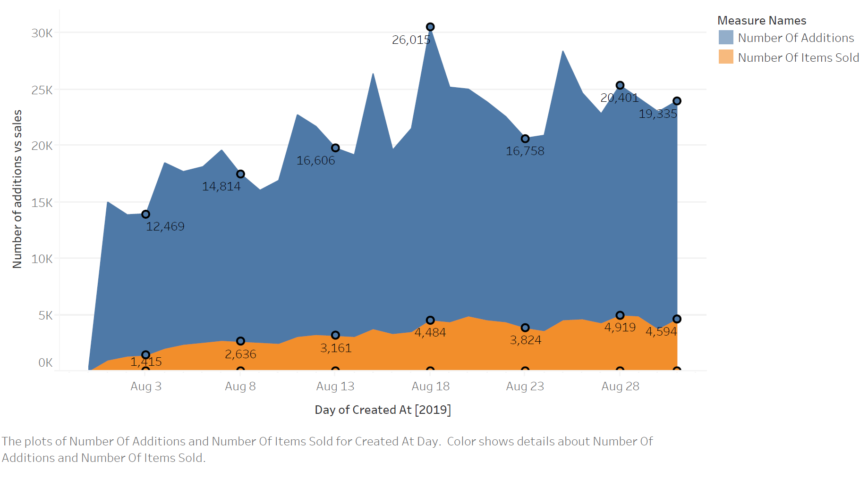

Fig. 1

The dynamic between our sellers and the buyers can be further explained by considering the ratio between daily new listings and sales. In fact, this ratio highlights the platforms ability to renew the inventory in a in the short run. While a high ratio of additions to sales may indicate low participation of from buyers, a relatively low ratio could indicate lack of confidence from potential sellers. Thus maintain an adequate ratio is primordial for the health of the platform.

In Fig 2, we denote that the ratio of daily acquisitions to daily sales decreases throughout the month before settling at approximately 4.2: 1.

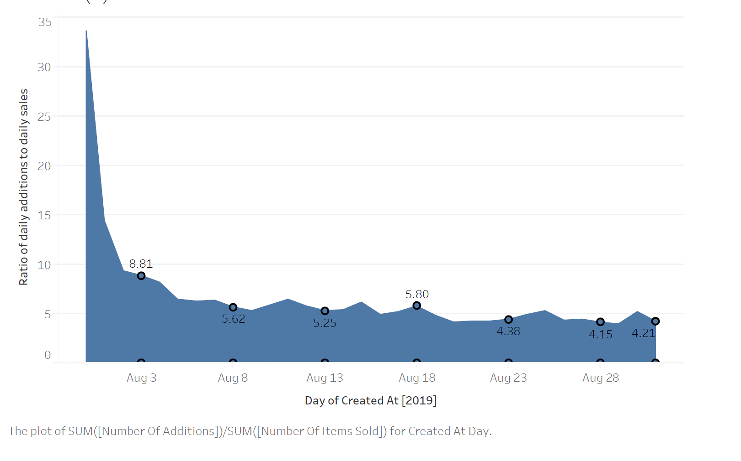

Fig 2.

# Liquidity (sellers perspective)

While monitoring daily activities can provide some insights regarding the interactions between sellers and buyers, a more in-depth study is required to understand the performance of the platform.

As a marketplace, Vinted strives to connect sellers and buyers in the most efficient way possible not only to maintain a healthy circulation of goods, but also to improve overall seller and customer satisfaction. On way to ensure this is to monitor the liquidity on the platform.

**We define liquidity as the percentage of items sold during a certain period on the platform or alternatively, in this report, as the number of days an item remains on the platform before sale.**

**We chose this metric as it provides us with insights on the sellers’ performance and ultimately, their satisfaction level.**

There are multiple benefits in reducing the amount of time to match a buyer and a seller:

1. Sellers that conclude a sale in a reasonable amount of time are incentivised to list more items
2. Sellers with a positive experience and feel confident in their ability to sell on Vinted may refrain from listing products on competition marketplaces
3. Rapid sales may have a cascading effect where customers react faster to secure a purchase
4. Satisfied sellers are more likely to purchase on Vinted

As shown in Fig 3, 9 percent of all new listings during the month of August were sold in less than a day and 0.263 percent of all new listings remained on the platform for 20 days before being sold. The shape to the curve indicates that the data is heavily skewed to the right.

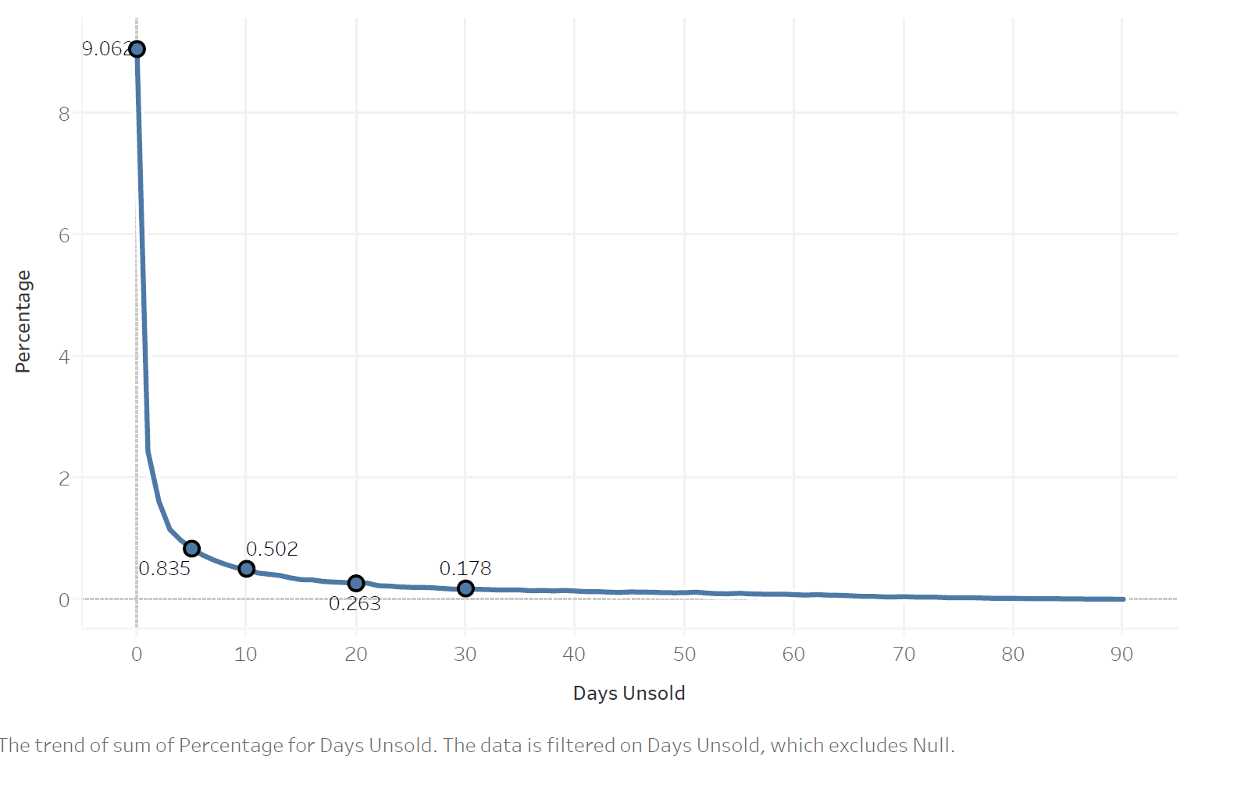

Fig 3.

Fig 4 offers a more intuitive illustration of the metric.

15.23 percent of all new items during the month of August were sold after remaining on the platform for a period of 10 days. Ultimately, 29 percent of all items were sold within a period of 90 days on the platform.

We note that 70 percent of all items remained unsold during the observed period.

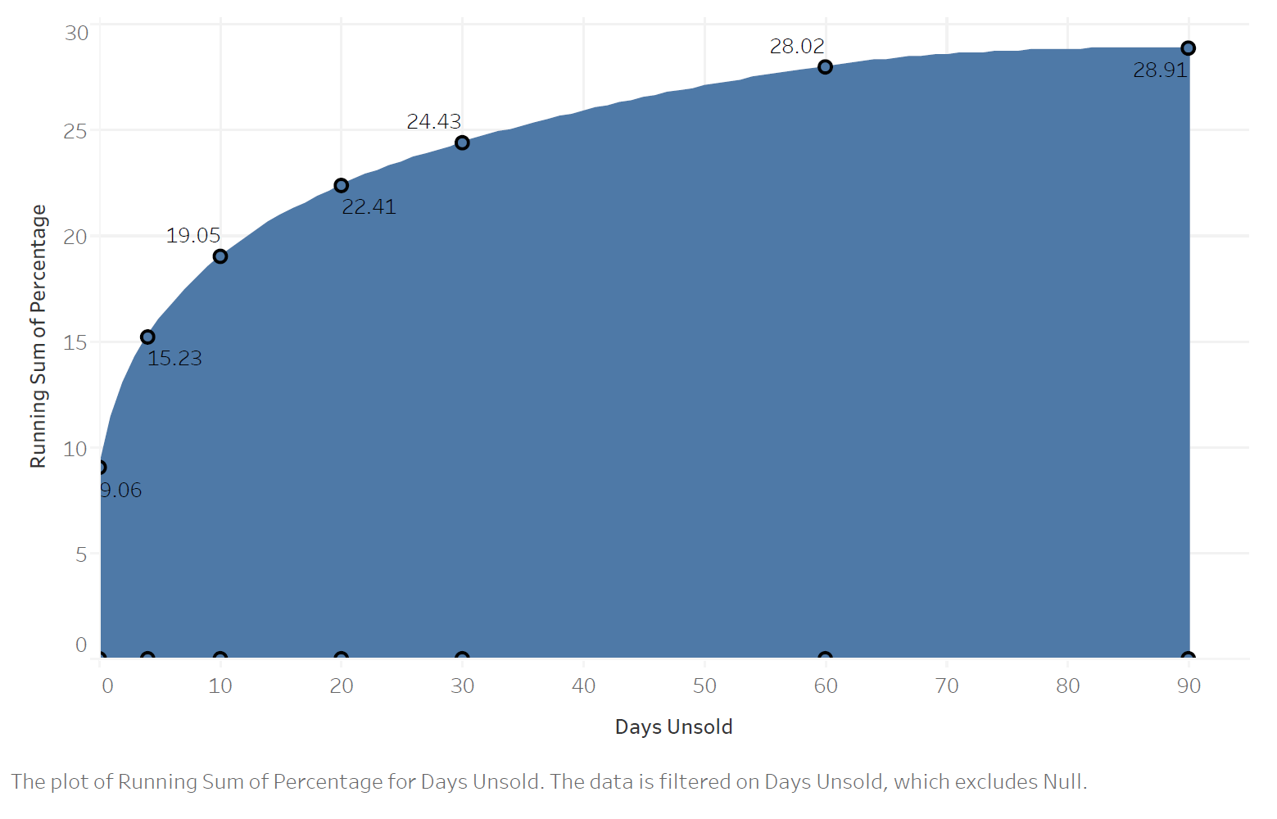

Fig 4.

# Metric

In order to improve our metrics, we investigate the main contributing factors by means of descriptive statistics. Detailed results of our findings can be found in the ‘Report_python.xlsx’ attached to this report or in the appendix.

Country_code

The users country affect was one of the main factors affecting our metric. The median number of days an item remain unsold was 6 days in Belgium as compared to 4 days in both France and Spain. Our model confirmed these results whereby France and Spain were associate with a lower count of days_unsold.

This issue may be tackled by further incentivising customers based in Belgium though targeted advertising, sales coupons or dedicating more resources towards brand verification.

Brand_is_verifed

Both our model and statistical analyses showed that bend verification instilled confidence in the buyer and expedited the selling process. The difference in median was roughly 1 day.

Introducing the concept of ‘verified seller’ could potentially induce more customer confidence.

Listing platform

The data showed that sellers listing items through the Iphone interface successfully completed their sales in a shorter period.

This may be due to several factors ranging from the ability to post high-resolution photos from a handheld device to differences between the Vinted app interface on Android and Iphone.

Status

Buyers responded more favourably to items marked “New with tags” and “mint”. Sellers should be incentivised to post items that corresponds these categories.

# Further considerations - Methodology

Future researching a more appropriate model to quantify the impacts of the factors identified should be the next steps.

For instance, a zero inflated poisson model is more appropriate for datasets with categorical independent variables and a high frequency of 0’s in the dependent variable.

## Appendix

|  |  |  |  |  |  |
| --- | --- | --- | --- | --- | --- |
|  |  | **days_unsold** | | | |
|  |  | **mean** | **median** | **std** | **var** |
|  |  |  |  |  |  |
| **country_code** | **BE** | 13.51678 | 4 | 18.5987 | 345.9115 |
| **ES** | 14.53566 | 6 | 19.1588 | 367.0595 |
| **FR** | 12.31518 | 4 | 17.77879 | 316.0853 |
| **listing_quality_string** | **Long description** | 10.59864 | 3 | 16.00939 | 256.3007 |
| **Long description, More than 2 photos** | 14.79232 | 6 | 19.17978 | 367.8639 |
| **More than 2 photos** | 13.45784 | 4 | 18.52448 | 343.1565 |
| **listings_in_first_7days_detailed** | **a. Didn't list over first 7d** | 12.46503 | 4 | 17.95524 | 322.3905 |
| **b. 1 listing** | 11.89829 | 3 | 17.30555 | 299.482 |
| **c. 2-5 listings** | 12.12653 | 4 | 17.70337 | 313.4094 |
| **d. 6-10 listings** | 12.69059 | 4 | 17.92163 | 321.185 |
| **e. 11-20 listings** | 12.43076 | 4 | 17.92989 | 321.4808 |
| **f. 21-50 listings** | 12.70055 | 4 | 17.84315 | 318.3779 |
| **g. 51-100 listings** | 12.26118 | 4 | 17.78363 | 316.2576 |
| **h. 101-500 listings** | 14.38033 | 6 | 18.70923 | 350.0354 |
| **i. 500+ listings** | 3.223881 | 0 | 8.80224 | 77.47942 |
| **brand_is_verified** | **FALSE** | 13.22582 | 4 | 18.41534 | 339.1248 |
| **TRUE** | 12.17159 | 3 | 17.66922 | 312.2012 |
| **listing_platform** | **android** | 12.90117 | 4 | 18.16771 | 330.0658 |
| **iphone** | 11.92768 | 3 | 17.52121 | 306.9928 |
| **web (desktop or other)** | 13.42976 | 5 | 18.46447 | 340.9365 |
| **status** | **a. New with tags** | 11.62795 | 3 | 17.262 | 297.9766 |
| **b. New** | 12.65608 | 4 | 17.982 | 323.3523 |
| **c. Mint** | 12.49032 | 4 | 17.93886 | 321.8025 |
| **d. Very good** | 12.72759 | 4 | 17.99293 | 323.7456 |
| **e. Good** | 13.04225 | 4 | 18.18207 | 330.5875 |

Statistical analysis - main factors

|  |  |  |  |  |  |  |
| --- | --- | --- | --- | --- | --- | --- |
|  | **coef** | **std err** | **t** | **P>|t|** | **[0.025** | **0.975]** |
| **Intercept** | 13.2224 | 0.359 | 36.873 | 0 | 12.52 | 13.925 |
| **C(country_code)[T.ES]** | 1.4188 | 0.45 | 3.152 | 0.002 | 0.536 | 2.301 |
| **C(country_code)[T.FR]** | -1.9324 | 0.24 | -8.04 | 0 | -2.403 | -1.461 |
| **C(listing_platform)[T.iphone]** | -1.2731 | 0.128 | -9.968 | 0 | -1.523 | -1.023 |
| **C(listing_platform)[T.web (desktop or other)]** | 0.5446 | 0.247 | 2.206 | 0.027 | 0.061 | 1.029 |
| **C(brand_is_verified)[T.True]** | -1.9159 | 0.144 | -13.337 | 0 | -2.197 | -1.634 |
| **catalog_code_1[T.MENS]** | 0.5329 | 0.208 | 2.557 | 0.011 | 0.124 | 0.941 |
| **catalog_code_1[T.WOMEN_ROOT]** | 1.2223 | 0.138 | 8.879 | 0 | 0.953 | 1.492 |
| **C(listing_quality_string)[T.Long description, More than 2 photos]** | 4.1502 | 0.2 | 20.787 | 0 | 3.759 | 4.542 |
| **C(listing_quality_string)[T.More than 2 photos]** | 2.9985 | 0.183 | 16.365 | 0 | 2.639 | 3.358 |
| **C(status)[T.b. New]** | 0.7138 | 0.227 | 3.147 | 0.002 | 0.269 | 1.158 |
| **C(status)[T.c. Mint]** | 0.3859 | 0.196 | 1.969 | 0.049 | 0.002 | 0.77 |
| **C(status)[T.d. Very good]** | 0.7679 | 0.237 | 3.235 | 0.001 | 0.303 | 1.233 |
| **C(status)[T.e. Good]** | 0.7907 | 0.478 | 1.653 | 0.098 | -0.147 | 1.728 |
| **window_items_sold** | -0.0068 | 0.001 | -6.846 | 0 | -0.009 | -0.005 |
| **listing_price_eur_fixed** | 0.0037 | 0.001 | 2.845 | 0.004 | 0.001 | 0.006 |

Regression Result (OLS – Categorical data)